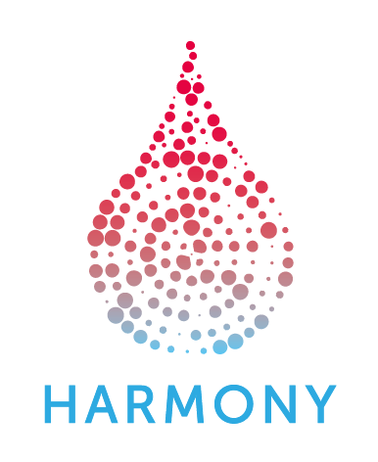
HARMONY 3rd General Assembly 2018

Agenda Friday, 5th October 2018
Hospital Universitario y Politécnico La Fe (HULAFE)

8:30-14 hrs: Room: Salón de Actos at Hospital La FE (Edificio Dirección, Administración y Docencia (Torre H)

8:30 – 9:00 Invited talk: Precision Medicine. A key factor to change the future of Healthcare
by Dr. Bernardo Valdivieso, Director of Strategic Planning
Hospital Universitario La Fe, Valencia, Spain

9:00 – 09:45 Providing data to the HARMONY Data Platform. Q&A session for Public and Private Data Providers
HARMONY Partners and Associated Members
Speakers: Gabriele Nagel, UULM; Jesús M. Hernández, IBSAL; Mirko Vukcevic, Novartis

09:45 –11:00 Update sessions: Achievements and Outlook – Disease Groups
WP | Speakers
WP2-AML&APL | Brian Huntly, University of Cambridge  Gert J.Ossenkoppele, VUMC  Francesco Lo-Coco, University Tor Vergata, Rome  Kalitsa Filoussi, Novartis
WP2-CLL | Sarka Pospisilova, Masarykova Univerzita  Thomas Marshall, AbbVie
WP2-MDS | Valeria Santini, University Firenze  Andrea Kündgen, Heinrich-Heine-University  Alberto Vasconcelos, Celgene
WP2-MM | Felipe Prosper Cardoso, University of Navarra  Mattia D’Agostino, UNITO  Bruno Costa, Celgene
ALL  Pediatric HMs | Anthony Moorman, Newcastle University  Dirk Reinhardt, GPOH  EFPIA contact tbd

11:00 – 11:30 Coffee Break

11:30 – 13:15 Update sessions: Achievements and Outlook – Work Packages

WPs | Speakers and Chairs
WP 3+4 | Rubén Villoria, GMV  Michel Van Speybroeck, Janssen  Rüdiger Hehlmann, ELN
WP5 | Gastone Castellani, UNIBO  Giulia Tonini, Menarini
WP6 | Jan Geissler, LeukaNet  Hélène Chevrou-Sévérac, Celgene
WP7 | Caren Smand, EHA  Ellen de Waal, EHA
WP8 | Christiane Druml, Medizinische Universität Wien  John Butler, Bayer

13:15 – 13:30 HARMONY Strategy and Roadmap for 2019
Speakers: Pam Bacon, Celgene; Guillermo Sanz, HULAFE

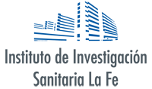
13:30 – 15:00 Networking Lunch
15.00 End of the 3rd General Assembly

